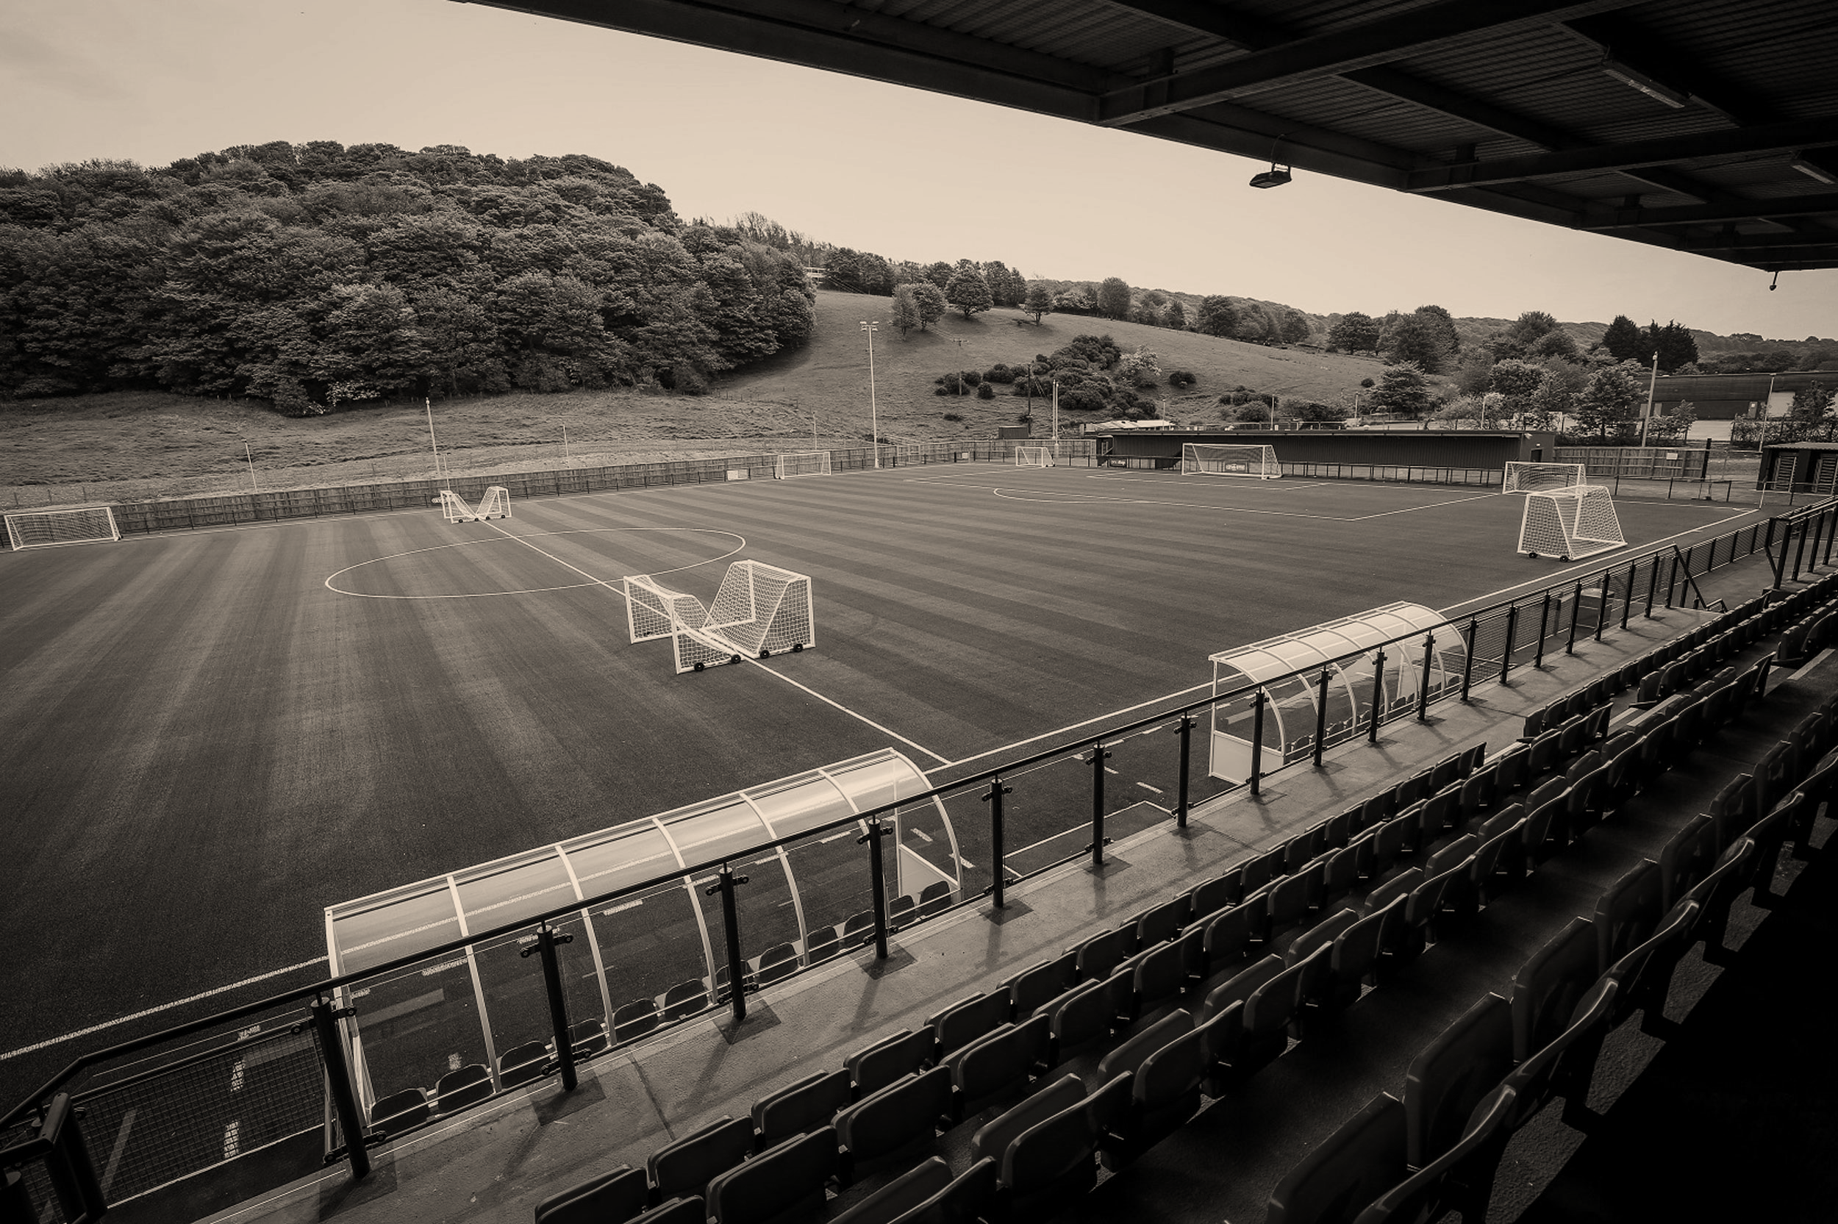



SPORTIZZA

Group Project I

SCS 2202

CS Group 19

### Group and Supervisor details

Proposed Project Supervisor

Name of the supervisor: Dr Shiromi Arunatileka

Email: sda@ucsc.cmb.ac.lk

Signature of the supervisor

Date: 06/25/2021

Proposed Project Co-Supervisor

Name of the co-supervisor: Mrs Ishani Fonseka

Email: cli@ucsc.cmb.ac.lk

Signature of the co-supervisor

Date: 06/23/2021

### Group Number & Members Details

Group Number: 19

|  |  |  |  |  |
| --- | --- | --- | --- | --- |
| 1. | Index Number: | 19001942 | Name: | W. L. P. MANETH WIJETUNGA |
| 2. | Index Number: | 19000286 | Name: | J. P. M. DASS |
| 3. | Index Number: | 19001312 | Name: | H.B.S. BHASHITHA RANASINGHE |
| 4. | Index Number: | 19000782 | Name: | K. P. D. PRASAD LAKSHAN |

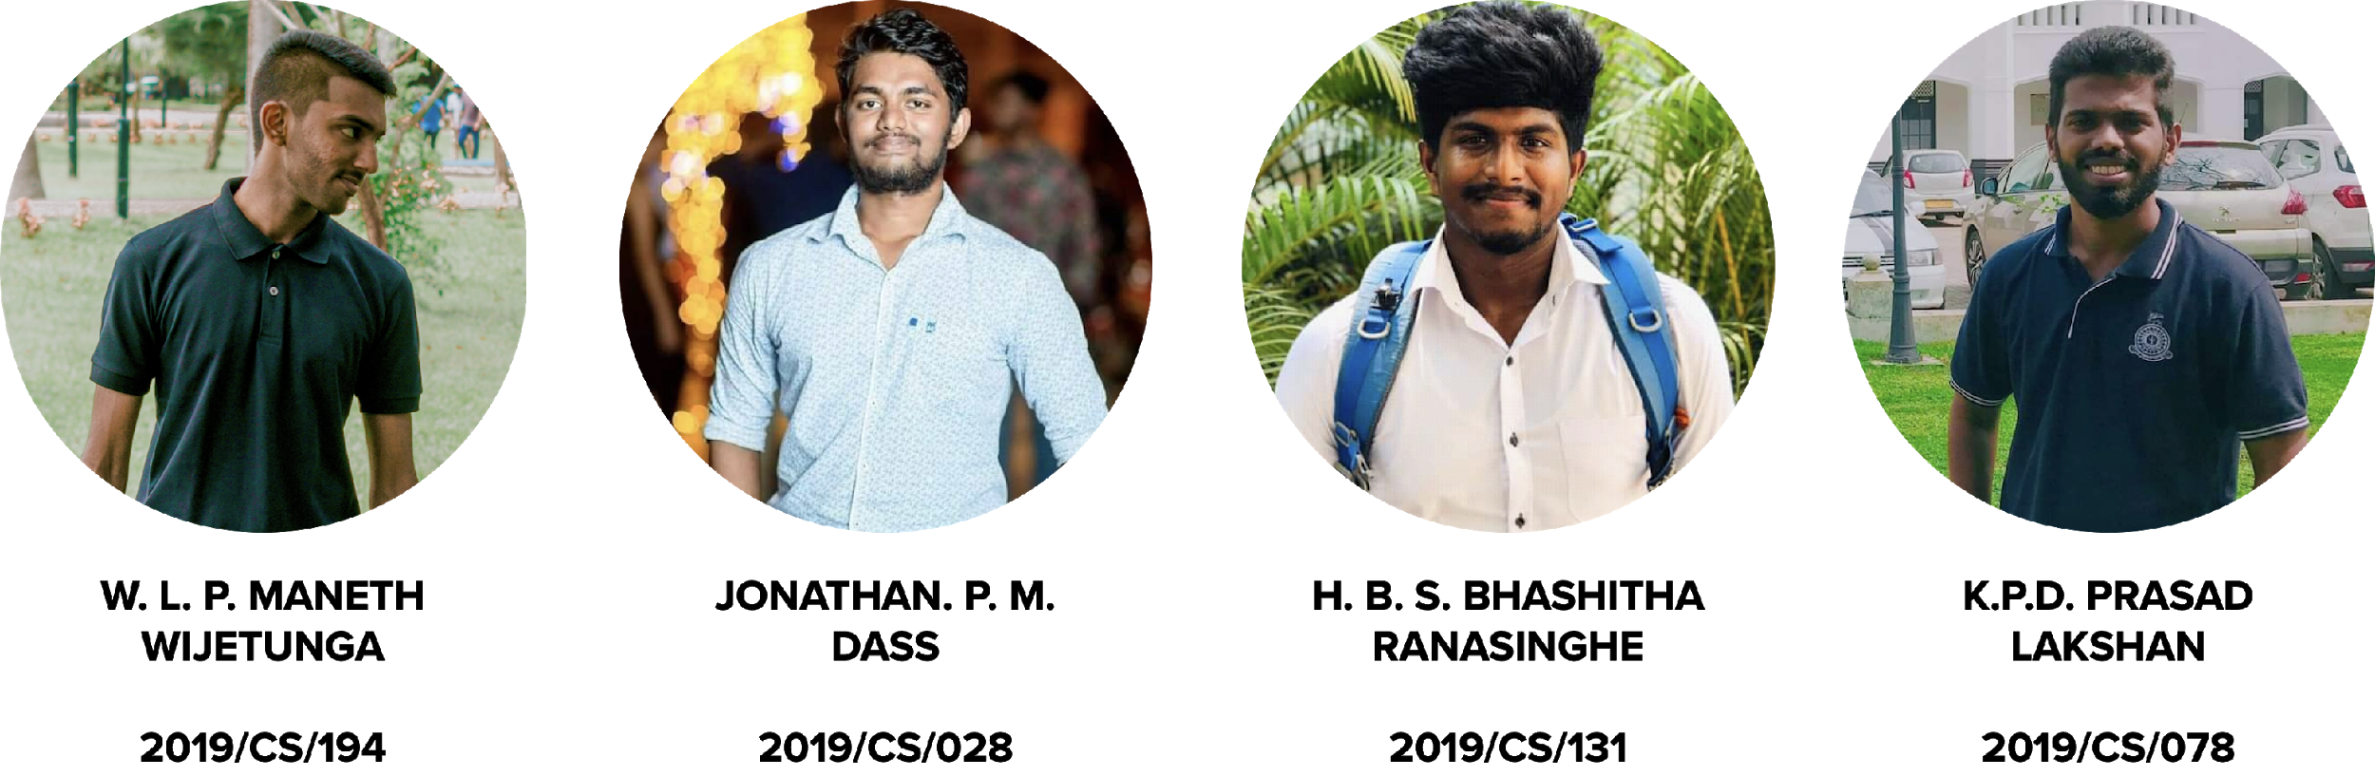

Table of Contents

Group and Supervisor details 1

Group Number & Members Details 1

Introduction to Project 3

Project Goal 4

Scope of the project 5

3.1 Main users 5

3.2 In-Scope - Main functionalities 5

3.3 Out of Scope 6

3.4 Flow of events in the current context 6

3.5 Flow of events with Sportizza 7

Objectives of the project 8

Project feasibility 8

5.1 Technical Feasibility 8

IDEs: 9

Tools & Utilities: 9

Hardware: 9

5.2 Operational Feasibility 9

5.3 Legal & Ethical Feasibility 10

5.4 Social Feasibility 11

5.5 Economic Feasibility 14

5.6 Schedule Feasibility 14

Deliverables of the project 15

Project Constraints and Limitations 16

Requirements of the project 16

8.1 Functional Requirements 16

8.1.1 Component Diagram 19

8.1.2 Use Case Diagram 20

8.1.3 Activity Diagrams 43

8.2 Quality Attributes 61

8.2.1 Security 61

8.2.2 Availability 61

8.2.3 Modifiability 61

8.2.4 Performance 62

8.2.5 Testability 62

8.2.6 Usability 62

Technologies 63

9.1 Front-end development of the web application. 63

9.2 Back-end development of the web application. 63

9.3 CASE tools for the system development process. 64

Project Timeline 64

Declaration 65

# Introduction to Project

Currently, when making a booking to a sports arena, customers have to go through so much hassle by making calls to a significant number of sports arenas and check whether they have that particular time slot available in their sports arena and if not, what are the other time slots available. Perhaps, the customers must make another call to confirm the booking a few days prior.

To be more specific, these are the main issues faced by both the customers as well as sports arenas:

* No method to search the sports arenas around.
* No method to check the available time slots of a sports arena without giving a call to the sports arena.
* No method available to check the details, facilities available before using the facility.
* Sports arenas are experiencing issues due to sudden booking cancellation by the customers.
* Sports arenas to receiving any revenue for the bookings which were not utilized but made the bookings.
* No easy method for the sports arenas to emergency booking cancellations.

Therefore, we aimed at these issues and proposed a software-based solution namely “Sportizza” which would allow the customers to search the available sports arenas for a particular timeslot and make the booking then and there without making a single call. Additionally, the sports arena would also receive a guaranteed payment made on their allocated bookings. Some more added functionalities would also be included such as a rating system for the sports arenas, booking sharing to the other collogues via social media, etc. Similar systems are available in other countries like Oman, India, Ireland, UK, etc.

With the increased concise on health-concerned lifestyle among Sri Lankan population, demand for the sports arenas is on an upward trend. But in the current context, there is no such similar platform in Sri Lanka to connect them with the sports arenas to get their bookings done. Additionally, group members of this project themselves are facing this issue in their day to day life. That’s also one of the main motivations for our group to select this issue and propose a workable solution as responsible undergraduates from the University of Colombo School of Computing (UCSC).

# Project Goal

The ultimate project goal of carrying out this project is to provide a convenient and efficient mechanism for the potential customers to make bookings for sports arenas while supporting the sports arenas to operate effectively when it comes to booking handling related services and providing effective business insights for the sports arenas to operate competitively within the industry.

Over the long term, as a next step, we also have plans to expand the scope of the platform by adding more partners such as sports equipment merchants, sponsors for sports events, etc. However, due to resource constraints, those aspects won’t be covered under the currently proposed project.

# Scope of the project

This section provides an overview of what areas will be specifically covered by Sportizza platform and what areas will be out of its scope. There are mainly 6 users who will be using the system.

## 3.1 Main users

1. Admin
2. Visitor
3. Customer
4. Manager
5. Administration Staff
6. Booking Handling Staff

## 3.2 In Scope - Main functionalities

The areas that are not specifically handled by the system include:

* Registration and authentication.
* Search for sports arenas.
* Make bookings.
* Provide ratings to sports arenas.
* Share booking confirmation to colleagues via social media.
* Sports arena listing in the platform.
* Analytics generation for sports arenas.
* Payment processing for sports arenas.

## 3.3 Out of Scope

The areas that are not specifically handled by the system include:

* Discounts on booking time slots.
* Booking rescheduling.
* Advertising of open tournaments organized by the sports arena.
* Booking timeslots with coaches.
* Sports equipment merchandising.

Figure : Current flow

As mentioned earlier, the current sports arena booking system is a bit inconvenient for the customers as well as the sports arenas. The below elaboration includes how the process happens in the current context as per figure 1, without the Sportizza platform.

Firstly, the customer should call a sports arena and check whether it is available on the customer’s required time slot. If it’s available from the first call, the customer was lucky and he just has to make one more call to the sports arena at a later stage in a normal scenario.

However, in most cases, the customer has to make few more calls to other sports arenas and check the availability if the previous sports arena is not booked.

For the instance, let’s assume that a customer founds out an available sports arena for their required time slot after going through so much hassle. Then the customer has to provide their NIC number, name and mobile number when making the booking. Furthermore, the customer has to again give a call to the sports arena and confirm their bookings 3 days prior.

From the sports arena’s perspective, they would receive the corresponding payment only after the customer using the facility. There are scenarios where the sports arena couldn’t make any revenue as some customers have cancelled their bookings at the last minute and some customers haven’t used the facility for their booked time and ultimately all these events lead to loss of revenue and resources for the sports arena. That’s just a gist of how the current process happens in the practical environment.



Figure : New Flow

With the introduction of the Sportizza Platform, we expect the process to be smoother and more convenient for both the customer and the sports arena.

Firstly, the customer can book a time slot in 2 main methods as per figure 2. The customer has the option to search for a particular sports arena and selects a time slot or the customer can search for a timeslot and select a sports arena. After this stage, the customer is getting the option to select a required time slot to proceed with the booking.

One of the most critical aspects of our system is that anyone with an internet connection and a mobile device or a personal computer could search for the available time slot irrespective of whether they want to make a booking or not. However, only a logged-in customer would be able to proceed with the next stage, which is to make a booking via our platform.

When considering the payment option, Sportizza provides the authority for the sports arena to decide whether they accept cash payments, card payments or both. Only the card payments would be handled by our platform by incorporating the service of a third-party payment gateway.

After a successful payment process, the customer would receive a booking confirmation which could be shared with the customer’s colleagues who would be using the facility with him for that particular time slot. For the sports arenas that accept only cash transactions, Sportizza would send the same booking confirmation message to the customers and the customers could show that booking confirmation to the sports arena’s administration staff and make the payment for that booking. Thus, the risk of the cash payments is totally out of Sportizza responsibility.

The above-mentioned Sportizza is also allowing the customers to provide feedback on the sports arena after each booking so that the sports arena could keep on improving their service and provide a high-quality service to the customers from the next time onwards.

# Objectives of the project

Increased concise on living a healthy life with adequate exercises is on an upward trend from the recent years. As Sri Lankans, we also have a tendency in moving towards a more healthy nation. As a part of the long-term vision “Hope of building a healthy nation” we are planning to develop this Sports Arena booking platform Sportizza to get more of the populations to use the existing sports arena resources within the island.

Additionally, we aim to achieve the following objectives in our journey:

* Simple User Interface for the users.
* Make the sports arena booking procedure more convenient for the customers.
* Providing the above-mentioned sports arenas to improve their current facilities.
* Providing analytics to the sports arenas to take managerial decisions.

# Project feasibility

## 5.1 Technical Feasibility

In order to complete the project on time and meet the agreed deliverables, we have planned to use the following technologies such as HTML, CSS, PHP and JavaScript as our implementation techniques. All IDEs used for development are free and open source.

Laptops and desktops required to carry out the development with the relevant hardware requirements are owned by the group members.

### IDEs:

* XCode
* Visual Studio Code

### Tools & Utilities:

* XAMPP & MAMP
* Version management- GitHub
* Draw.io – UMLs & diagrams
* JIRA - To manage tasks among group members
* Adobe Illustrator- logo making
* Workbox – To offline caching in the Progressive Web Application
* Microsoft Office 365 (Student edition provided free for university email)
* Grammarly -Free edition to eliminate grammar mistakes
* Google Lighthouse – To audit the System

### Hardware:

* Personal laptops
* Routers

All the above-mentioned resources are easily usable within our knowledge limits. Hence the project is technically feasible.

## 5.2 Operational Feasibility

Firstly, for the proposed platform to be operationally feasible, all the identified functional requirements should be included in the software. Most importantly, the system should increase the convenience of the customers as well as the ground management staff for this system to be operationally feasible.

In order to use the system, there are certain aspects that have to be fulfilled by the users. They are as follows:

Users (Manager, Administration Staff from sports arena and the customers) should have a medium knowledge in IT and English.

A mobile device is required to access the platform.

If the sports arena’s manager and administration staff could have personal computers or laptops, it would be easier for them to carry out their operations via the proposed platform.

Affordability Vise, the ground sports arena is charged only 5% of each booking from the platform and if any other extra statistical reports are requested, they would get charged an additional fee depending upon the content requested. Customers won’t bear any fee throughout the process.

Additionally, one of the main aspects considered when developing this platform is to have a user-friendly interface including convenient navigation, performance, and mobile compatibility so that users can easily access the application using their smartphones.

By considering all these aspects, it's clear that our proposed system is operationally feasible.

## 5.3 Legal & Ethical Feasibility

The proposed system will contain large databases of sensitive user data such as the bank details of the sports arena management and payment details of the customers. We have to protect our databases from unauthorized intruders and also guarantee the user’s privacy and confidentiality. As a remedy, we are planning to add all our privacy policies to our user agreement as per GDPR privacy laws. Hence the customers can read the agreement document before entering their data into our databases.

A hierarchically based login mechanism is to be used in the system so that only the relevant authorized users can view the data available to them. As an example, the booking handling staff would find only a limited number of features than the administration staff of the sports arena.

For online payments, the support of a third-party payment gateway is being used. Since it’s a trusted software that has already processed over Rs 1 billion worth of transactions, it's safe to assume that all the transactions could be done with rusted, standardized payment providers over a secured connection.

In order to complete the proposed project, we are planning to use many open-source applications services. We have to be concerned about their guidelines and agreements.

Hence, our system is legally and ethically feasible.

## 5.4 Social Feasibility

We have performed a survey to identify the impact and the intensity of this issue for society by using a google response form. As of now, we have received a total of 155 responses.

Below are a few of the analytics which we derived from the responses we received:

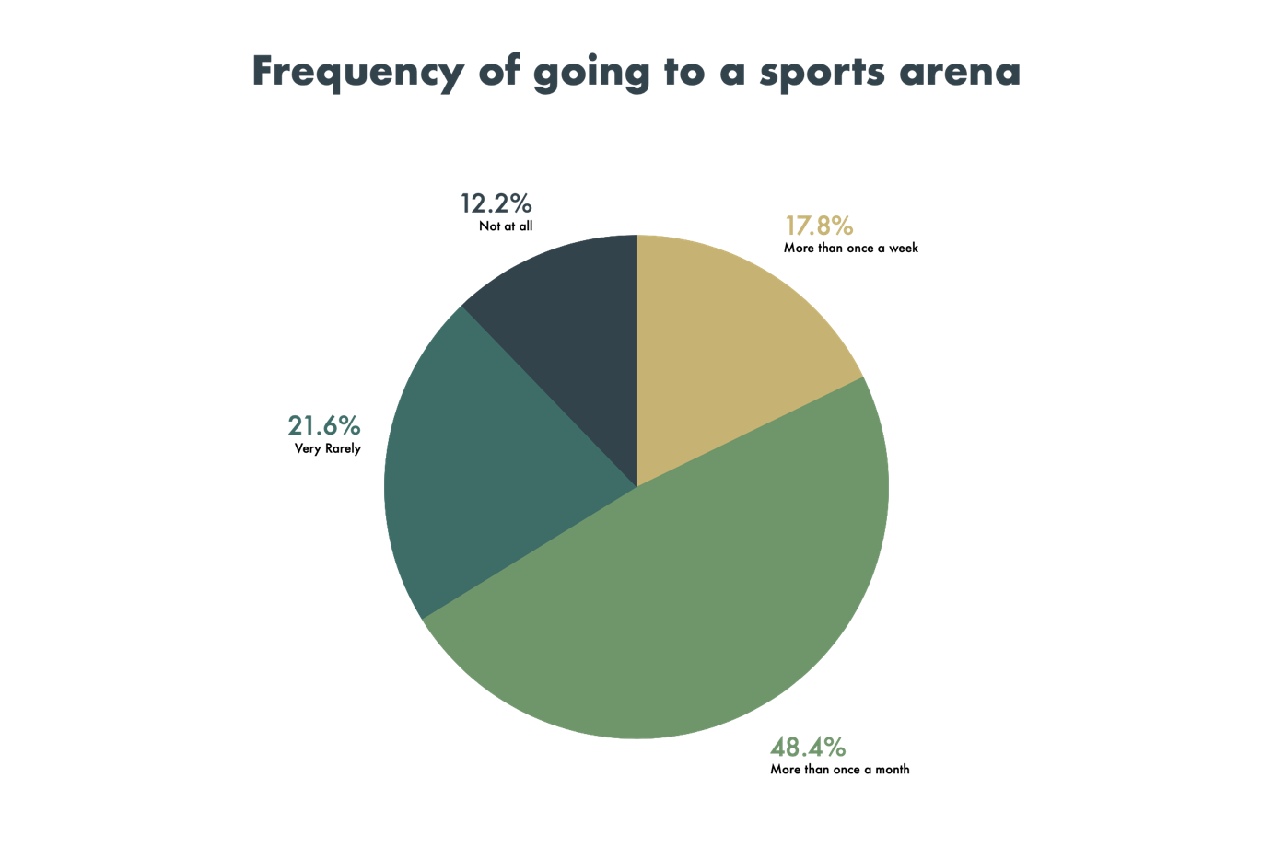

Figure 3: Pie Chart 1 from response sheet

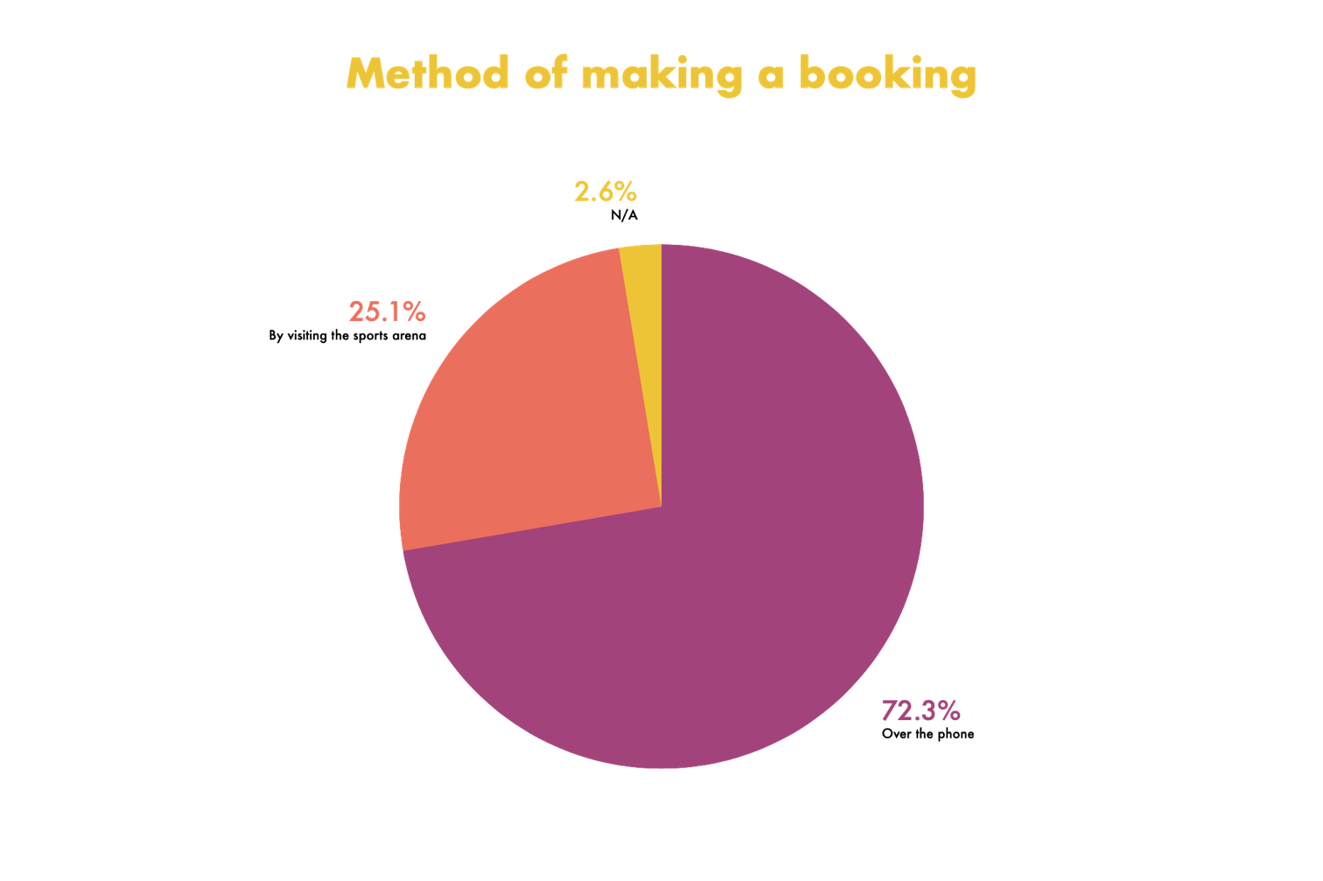

Figure 4: Pie Chart 2 from response sheet

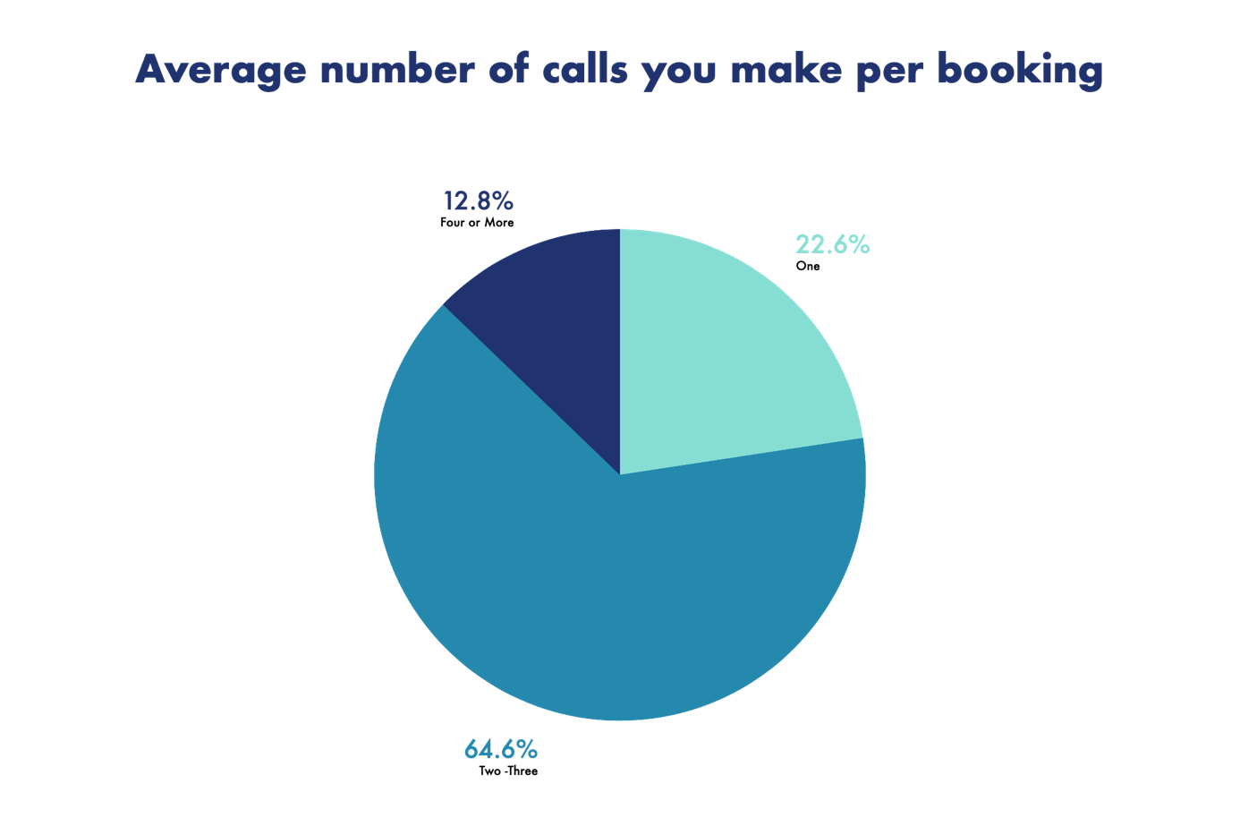

Figure 5: Pie Chart 3 from response sheet

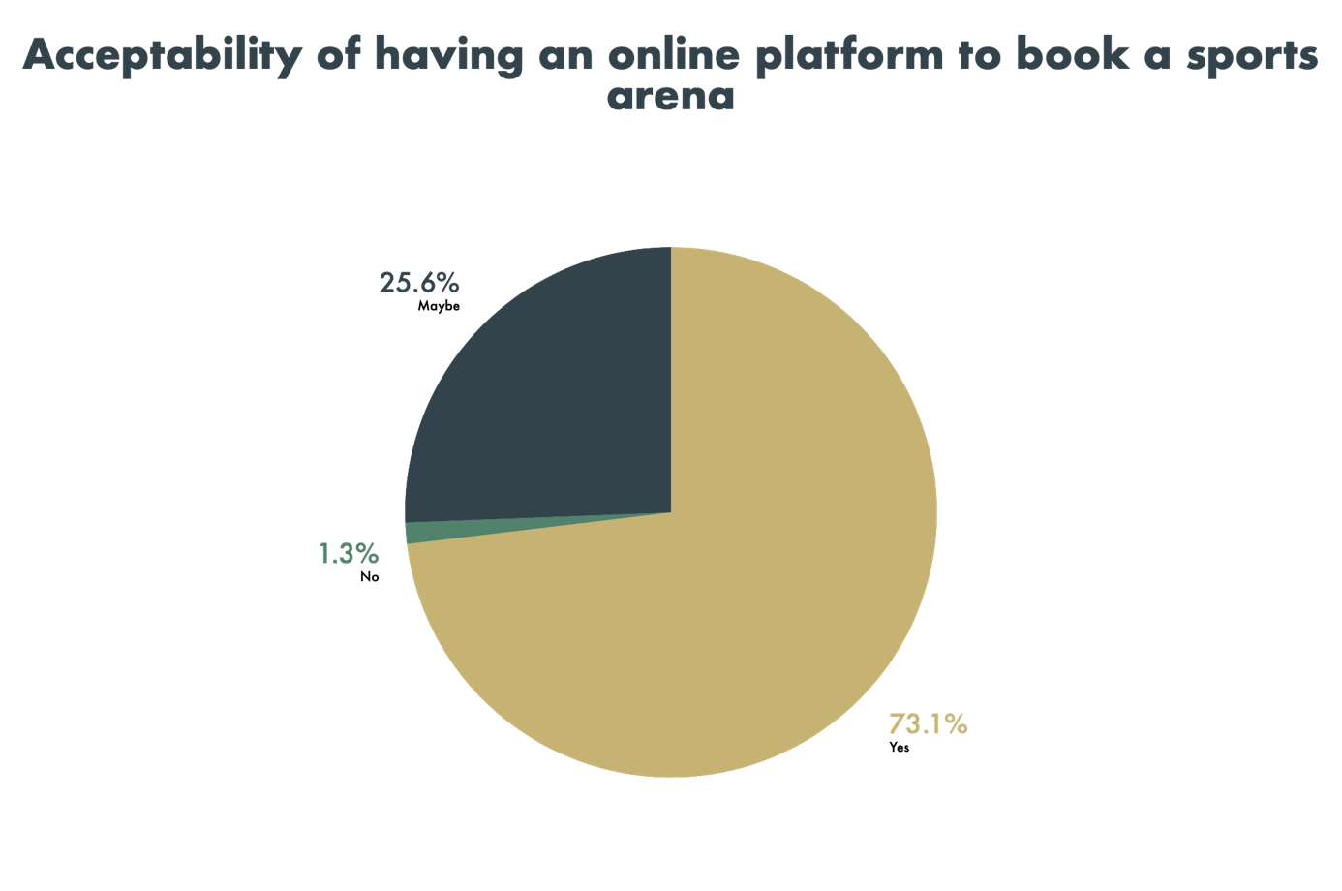

Figure 6: Pie Chart 4 from response sheet

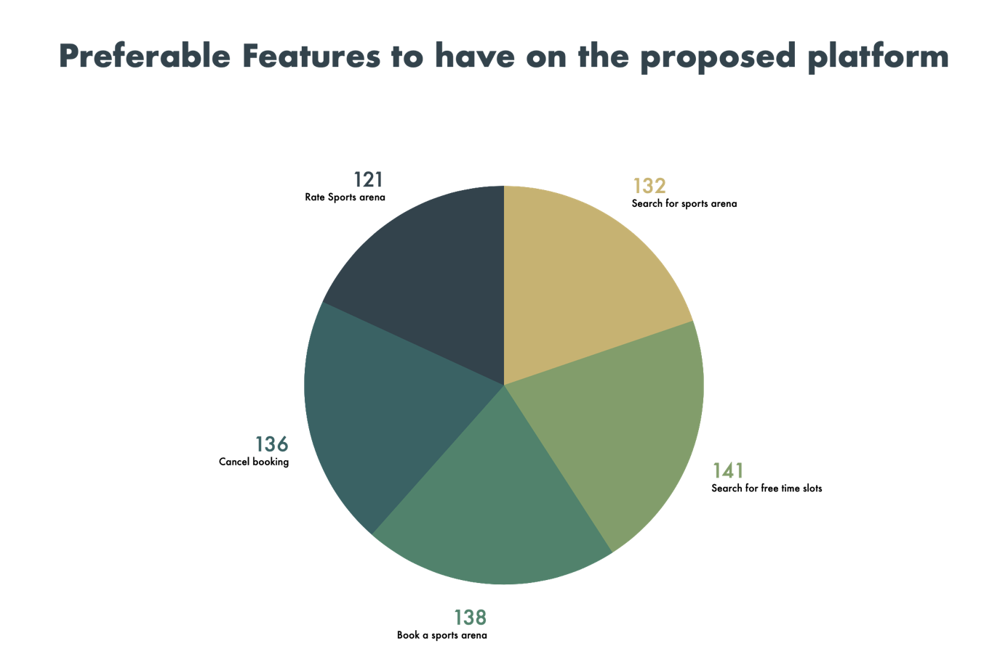

Figure 7: Pie Chart 5 from response sheet

As per figure 3, it is clear that more than 66% of the people are visiting a sports arena more than once a month. This aspect signifies how important our platform for society. Furthermore, as per figure 4, most of the people are currently making the booking via phone calls and the rest is making the booking by visiting the sports arena. Both groups could make bookings and search for sports arena(s) from our platform.

When it comes to booking, 64.6% of the responses have shown us that they make an average of 2-3 calls for each booking. This may include the first call to check for the sports arena’s availability and the second one again to make the booking and the other one may be to confirm the booking three days prior. Additionally, we have also taken the responses of the society of whether they think our platform would solve their issue. This is being depicted in figure 6. Amazingly, 73.1% said “Yes” to our solution. As their preferable features, we received the voting more or less the same for the above 5 features orderly Search for free timeslots, book a sports arena, Cancel booking, Search for sports arenas and rate sports arena.

By considering all these facts, it seems that our project is socially feasible.

## 5.5 Economic Feasibility

Since Free & Open-Source Software are used for development, it won’t cost anything related to the development.

When deploying the system, the cost of hosting the web application or for any other hardware equipment would be ideally nil as we are planning to use the Free tier of “Amazon Web Services” (AWS) to deploy the system. Eventually, once the user base grows, the system would be updated to the paid versions which would depend upon the user base.

For payment gateway, we are planning to use the “PayHere” sandbox and it’s also freely available at the moment.

Therefore, our system is economically feasible.

## 5.6 Schedule Feasibility

The time duration allowed for this project is 10 months. All the work has been divided among the 4 group members and it’s anticipated to finish our project by the end of March 2021.

Below is the Gantt chart prepared with respect to our project.

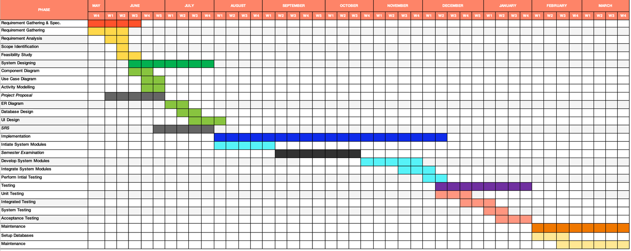

Figure 8: Gantt Chart

|  |  |  |
| --- | --- | --- |
| Number of individual work hours (per week) | = | 10h |
| Number of work hours as a team (per week) | = | 40h |
| The estimated number of weeks | = | 30 |
| The estimated total of man-hours | = | 1200h |
| Risk buffer | = | 240h |
| Budgeted Time | = | 1440h |

# Deliverables of the project

* Progressive Web Application (PWA).

Progressive Web Application, where users can create their accounts and log in to the system. All the roles in the system can interact with the system through the web application.

* User manuals for the sports arenas with screenshots attached.

Containing all the instructions, the user manual will be provided to all the sports arenas that are getting listed themselves on our platform.

* License Agreement of the Application.
* Appropriate License for the software.
* Software Requirement Specification (SRS).

Including the problem background, objectives to be achieved upon completion, feasibility study, scope, functionality and quality attribute and design specifications illustrated with various diagrams.

# Project Constraints and Limitations

Through the proposed platform, only the registered users would be allowed to make a booking and for that, every customer should have an available mobile phone number for verification processes.

Since the authority to choose the payment option is fully granted to the sports arena’s manager and the administration staff, any issues involved with the cash payments aren’t handled and not taken responsibility by the Sportizza platform.

Also, the customers are not allowed to reschedule their bookings. Instead, the customers could cancel their current booking, if permitted by the guidelines and make a new booking. Customers would receive their refunds within the next 14 days.

Some other additional features such as providing discount codes by sports arenas to attract customers advertise the sports tournaments organized by the customers and offering a facility to connect customers with relevant coaches are not currently considered under the project due to resource constraints.

Furthermore, government-controlled sports arenas which don’t allow the customers to book their facilities per a required time slot couldn’t be booked via the Sportizza platform.

One last limitation of this project would be that we are using the waterfall model to carry out this project as the requirements are stable enough and the industry itself is quite stable over the long term. On the flip side, the use of the waterfall model limits our team from providing frequent deliverables and it would ultimately increase the overall risk of arriving at the most relevant project by the time of deployment. However, we would always be willing to do any changes whenever required even though we use the waterfall model as a framework to structure the timeline of our project development.

# Requirements of the project

## 8.1 Functional Requirements

There are six main actors in the system,

1. Visitor
2. Customer
3. Manager of the sports arena
4. Administration staff of the sports arena
5. Booking Handling staff of the sports arena
6. Admin

Functional requirements according to the actors in the proposed system are stated below:

1. A visitor has the following functional requirements:

* Search for sports arenas
* Ask help/ support desk

1. A customer has the following functional requirements:

* Signup
* Login/ Logout
* Edit profile details
* Search for sports arenas
* Book sports arena
* Do a payment
* Share booking via social media
* Rate sports arenas and provide reviews
* Create my sports arenas list
* Cancel booking
* View my bookings
* Ask help/ support desk

1. The manager of the sports arena has the following functional requirements:

* Register for an account
* Login/Logout
* Edit sports arena profile
* Generate reports
* Choose payment method
* Reply to customer feedbacks and queries
* Booking slots manually
* View bookings
* Emergency booking cancellations

1. Administration Staff of the sports arena has the following functional requirements:

* Register for an account
* Login/Logout
* Edit profile details
* Choose payment method
* Reply to customer feedbacks and queries
* View bookings
* Booking Slots manually
* Emergency booking cancellations

1. Booking Handling Staff has the following functional requirements:

* Login/Logout
* View bookings

1. Admin has the following functional requirements:

* Login/Logout
* Verify sports arenas for listing
* Remove sports arenas
* Remove customers
* Remove negative feedbacks after assurance by the sports arena
* Help & support
* Generate System Reports

### 8.1.1 Component Diagram



### 8.1.2 Use Case Diagram

Use Case Diagram Assumptions:

* For every sports arena, 3 user account types are privileged namely Manager, Administration Staff and Booking Handling Staff with respective levels of privileges to operate the sports arena’s day-today activities.
* When verifying a sports arena, the admin has to manually verify the details from the sports arena manager or the administration staff and also should do background checks about the details of the sports arena.
* Cash payments are not handled via the Sportizza platform.
* Once a booking is cancelled, refund fee for the customer would be provided after 14 days.



8.1.3 Use Case Descriptions

|  |  |
| --- | --- |
| Use-Case Name | Sign Up for Customer Account |
| Use-Case ID | 01 |
| Summary | The user can create their profiles. |
| Actors | Visitor |
| Pre-Conditions | The user must visit the platform. |
| Course of Events | 1. The user enters the relevant personal details including the mobile number. 2. Verify the mobile number with a verification code. 3. Activate the user account. |
| Exceptions | If the mobile number entered is invalid, or already has an account with the mobile number, then the user has to try again. |
| Post-Conditions | The user gets redirected to his/her account. |

|  |  |
| --- | --- |
| Use-Case Name | Login |
| Use-Case ID | 02 |
| Summary | User can login to the system |
| Actors | Customer, Book Handling Staff, Administration Staff, Manager, Admin |
| Pre-conditions | User must have an account  User must not be currently logged into the system |
| Course of Events | 1. User clicks the relevant login icon  2. User submits a form displayed with username and password. (For sports arena, they should enter the sports arena name too).  3. System checks whether the username and hash password provided matches with those in the database  4. Start a session |
| Exceptions | If the credentials entered are invalid, an error message pops up |
| Post-conditions | User will be logged into the system under the relevant privilege. |

|  |  |
| --- | --- |
| Use-Case Name | Edit profile |
| Use-Case ID | 03 |
| Summary | The user can edit profile details |
| Actors | Customer. |
| Pre-Conditions | The user must be currently logged into the system. |
| Course of Events | 1. Go to my profile and select the details the user wants to change. 2. If it's a username, check the availability of the new username. 3. If it’s a mobile number, verify the mobile number via a system generated code. 4. If it’s a password, verify the password. |
| Exceptions | If the user can’t verify, the user can try again. |
| Post-Conditions | If process successful Display “Edit profile is successful” |

|  |  |
| --- | --- |
| Use-Case Name | Search for Sports Arena |
| Use-Case ID | 04 |
| Summary | The user can search for sports arenas and available time-slots. |
| Actors | Visitor, Customer. |
| Pre-Conditions | The user must visit the platform. |
| Course of Events | 1. Enter the Sports Arena name. 2. Enter filters such as category, sports arena, date and perform the search. 3. Display the matched results. 4. Select the preferable time slots. 5. Check the available facilities of the sports arena. |
| Exceptions | Alternatively, can enter the name of the sports arena and search too. The user can select a sports arena and view additional details of that particular sports arena. Furthermore, a user can add a sports arena to my favorite list. |
| Post-Conditions | The user can book a required time slot(s) if it's a customer. |

|  |  |
| --- | --- |
| Use-Case Name | Booking sports arena. |
| Use-Case ID | 05 |
| Summary | The user can book a sports arena. |
| Actors | Customer. |
| Pre-Conditions | The user should be logged in to the search window of the site. |
| Course of Events | 1. The user can view the available time slots.  2. The user can select a booking slot.  3. The user can confirm booking.  4. If the sports arena requires card payments, the system will redirect the user to the payment gateway. (Cash payments are handled after using the facilities).  5. User’s mobile will receive an SMS with the booking details. |
| Exceptions |  |
| Post-Conditions | After booking a slot, if the sports arena allows only card payments, the user will get directed to the payment gateway. Else, the user can share the booking details with the friends via social media. |

|  |  |
| --- | --- |
| Use-Case Name | Do Payment |
| Use-Case ID | 06 |
| Summary | The user can perform a payment to confirm the booking. |
| Actors | Customer. |
| Pre-Conditions | The user should select an available time slot. |
| Course of Events | 1. The customer will enter the relevant card details. 2. Relevant amount gets transferred to the system’s account. (Every two-weeks, all due amounts are credited to the sports arenas’ accounts. 3. The customer will receive a notification “payment successful”. |
| Exceptions | The transaction might get declined if the card details are invalid or due to insufficient balance. Also after 2 minutes, the payment window gets expired (Timed out). |
| Post-Conditions | The user will get the option to share the booking details with friends via social media. |

|  |  |
| --- | --- |
| Use-Case Name | Share booking |
| Use-Case ID | 07 |
| Summary | The user can share a booking via social media. |
| Actors | Customer |
| Pre-Conditions | The user should have made a booking via the site. |
| Course of Events | 1. The user could select the share option respective to the booking. 2. Alternatively, the user can click to share my booking after successfully completing a payment with the respective booking. 3. The user can select the respective social media platform and share it with the relevant parties. |
| Exceptions | Sharing might get declined if a valid social media account doesn’t exist. |
| Post-Conditions | The user gets redirected to his/her account. |

|  |  |
| --- | --- |
| Use-Case Name | Cancel Booking |
| Use-Case ID | 08 |
| Summary | The user can cancel booking and must enter the reason for cancelling reason |
| Actors | Customer. |
| Pre-Conditions | User must be currently logged into the account  Booking must have at least three days (72 hours) for the booking day before cancellation. |
| Course of Events | 1. User can select the booking from my booking list 2. Click cancel booking icon 3. Enter the reason for cancellation 4. System sends a verification code 5. Enter verification code 6. Display refund information 7. System changes the booking slot an available time slot. |
| Exceptions | If the user couldn’t enter a valid verification code, the user can try again. If it’s a cash transaction, no refund is made. |
| Post-Conditions | If process successful Display “cancel booking is successful”.  If not successful display “You are not allowed! You have passed the cancellation period”. |

|  |  |
| --- | --- |
| Use-Case Name | Rate Sports arena |
| Use-Case ID | 09 |
| Summary | The user can provide a rating to a sports arena. |
| Actors | Customer |
| Pre-Conditions | The customer should have done a booking for a particular sports arena and the customer should have used its service. |
| Course of Events | 1. After the finish time of the booked time slot, the site will pop up with a feedback sheet. 2. If clicked the cancel button at that time, the user can alternatively view his/her past bookings over my bookings segment in their profile and select the rating option from the booking. 3. The user can click and provide a star-rating. 4. Optionally, the user can enter any feedback too. 5. The user could submit the feedback or alternatively cancel the option. |
| Exceptions |  |
| Post-Conditions | Customer rating will get added to the sports arena’s profile and to the average rating of that sports arena. |

|  |  |
| --- | --- |
| Use-Case Name | Help & Support |
| Use-Case ID | 10 |
| Summary | After an administration staff, manager or a customer posts an issue, the admin will follow the issue and will provide necessary solutions. |
| Actors | Administration Staff, Manager, Customer, Visitor, Admin |
| Pre-Conditions | A complete and reasonable issue must be available. |
| Course of Events | 1. The user can post their issues if it's not answered on the site under FAQs. 2. The user gets notified that the question is successfully posted. 3. Admin will get notified about the posted issue. 4. If it’s a new complaint, generate a complaint reference number. 5. System sends the complaint reference number. 6. Admin will provide necessary solutions. 7. The user will get notified with the solution for their issue. |
| Exceptions | If any such similar issue is not available under the FAQs, Admin can add the questions to the FAQs depending on the relevance. |
| Post-Conditions | The issue will be marked as answered. |

|  |  |
| --- | --- |
| Use-Case Name | View My Bookings |
| Use-Case ID | 11 |
| Summary | Customer can view their bookings through their profile. |
| Actors | Customer |
| Pre-Conditions | The user must be logged in to the system. |
| Course of Events | 1. User can go my profile. 2. Select My bookings. |
| Exceptions |  |
| Post-Conditions | The user will get directed their profile once the back button is clicked. |

|  |  |
| --- | --- |
| Use-Case Name | Register a Sports Arena account |
| Use-Case ID | 12 |
| Summary | Authorized people from a particular sports arena can create their respective sports arena’s profiles. |
| Actors | Administration Staff, Manager, Admin |
| Pre-Conditions | The user must not have a listed sports arena with the same name and address under the same category. |
| Course of Events | 1. User enters the details of the sports arena including name, address of the sports arena, category of sport(s), equipment availability, other facilities, payment option, etc. 2. Submit the application. 3. Admin clicks on the applied sports arena application. 4. Contact the sports arena. 5. Verify the sports arena via Google Maps and other methods. 6. Accept the sports arena account if successfully verified. 7. List the account on site. 8. User has the option to add user accounts to the sports arena account. |
| Exceptions | If sports arena’s details aren’t properly verified, quit the process, and notify the applicants. Applicants could try again. |
| Post-Conditions | The user will get notified once the sports arena is listed on the site after the manual verification process and will get re-directed to the homepage. |

|  |  |
| --- | --- |
| Use - case Name | Edit Sports Arena Profile |
| Use - case ID | 13 |
| Summary | User edits the details, pictures, and features(facilities) in the profile. |
| Actors | Manager, Administration Staff |
| Pre-conditions | The user must be currently logged into Edit Window in the system. |
| Course of Events | 1. Select the Detail to want to change 2. Change the detail 3. Verify the validity of the detail 4. Save and end the session 5. User receives successful notification |
| Exceptions | If the changing detail is not valid, then the user can try with a different value. If the user going to change the sports arena address, that cannot be done and get a notification to delete the profile and create a new profile. |
| Post-conditions | User gets redirected to the sports arena profile. |

|  |  |
| --- | --- |
| Use - case Name | Make Bookings via Sports Arena |
| Use - case ID | 14 |
| Summary | The user can book a time slot manually. |
| Actors | Manager, Administrations Staff |
| Pre-conditions | The user must be currently logged into the system.  The time slot must be free. |
| Course of Events | 1. View Booking slots. 2. Select the time slot. 3. Enter the customer details. 4. Get the payment (optional). 5. Book the time slot. 6. Send the Notification. |
| Exceptions | If the time slot is not free, the booking cannot be done. |
| Post-conditions | User gets redirected to the sports arena profile. |

|  |  |
| --- | --- |
| Use - case Name | View Booking |
| Use - case ID | 15 |
| Summary | The user views the bookings. |
| Actors | Manager, Administrations Staff, Booking handling Staff |
| Pre-conditions | The user must be currently logged into the system. |
| Course of Events | 1. Select view Bookings. 2. Filter the Bookings (optional). 3. Generate the Booking Table. |
| Exceptions |  |
| Post-conditions | User gets redirected to the sports arena profile. |

|  |  |
| --- | --- |
| Use - case Name | Emergency Booking Cancellation |
| Use - case ID | 16 |
| Summary | The User cancels the booking, because of an emergency |
| Actors | Manager, Administration Staff |
| Pre-conditions | The user must be currently logged into the System. |
| Course of Events | 1. Go to bookings 2. Select the Time period / Date. 3. Select the Booking. 4. Enter the reason for Cancellation. 5. Cancel the Bookings. 6. When canceling the booking, send a notification to the customers. |
| Exceptions | If the reason is not submitted, the booking cancellation cannot be done. |
| Post-conditions | User gets redirected to the sports arena profile.  Remove the sports arena from the search listings for that particular time period. |

|  |  |
| --- | --- |
| Use - case Name | Reply Customer Feedbacks |
| Use - case ID | 17 |
| Summary | The user reply to the feedback of the customers. |
| Actors | Manager, Administration staff |
| Pre-conditions | The user must be currently logged into the system.  There should be a valid feedback. |
| Course of Events | 1. Go the customer feedbacks 2. Select the relevant feedback 3. Reply to the feedback |
| Exceptions |  |
| Post-conditions | User gets redirects to the feedback page. |

|  |  |
| --- | --- |
| Use - case Name | Generate Reports |
| Use - case ID | 18 |
| Summary | The ground manager can get the reports |
| Actors | Manager |
| Pre-conditions | The user must be currently logged into the System. |
| Course of Events | 1. Select the relevant time period. 2. Select the statistics. 3. Obtain the generated reports. |
| Exceptions |  |
| Post-conditions | User gets redirected to the sports arena profile. |

|  |  |
| --- | --- |
| Use-Case Name | Remove Negative Ratings |
| Use-Case ID | 19 |
| Summary | Admin can remove negative ratings of the sports arena |
| Actors | Admin |
| Pre-conditions | Admin must be currently logged into the system.  A sports arena should have negative reviews. |
| Course of Events | 1. User checks on the negative reviews of the sports arena.  2. User contacts sports arena to inform them.  3. Wait until the changes mentioned are done.  4. After confirmation, remove the ratings |
| Exceptions | If the changes are not made within the requested time period, then blacklist the sports arena. |
| Post-conditions |  |

|  |  |
| --- | --- |
| Use-Case Name | Remove Sports Arena Account |
| Use-Case ID | 20 |
| Summary | Admin can remove sports arenas |
| Actors | Admin |
| Pre-conditions | There should be an existing sports arena account.  The user should be logged in to the system.  The sports arena account should be blacklisted. |
| Course of Events | 1. View complaints of a Sports Arena.  2. If the sports arena is in blacklist, remove the account.  3. Admin clicks on the sport arena profile.  4. Remove account.  3. Notify the sports arena. |
| Exceptions | If the sports arena is not in blacklist, notify the sports arena without removing. |
| Post-conditions | The sports arena would be removed from the system |

|  |  |
| --- | --- |
| Use-Case Name | Remove Customers |
| Use-Case ID | 21 |
| Summary | Admin can remove customer accounts |
| Actors | Admin |
| Pre-conditions | A customer not abiding by the terms & conditions. |
| Course of Events | 1. Admin clicks on the customer account to be removed.  2. Remove the customer account.  3. Notify the customer via an SMS. |
| Exceptions |  |
| Post-conditions | Removed customer would no longer be a customer of the system. |

|  |  |
| --- | --- |
| Use-Case Name | Logout |
| Use-Case ID | 22 |
| Summary | User can log out of the system |
| Actors | Customer, Book Handling Staff, Administration Staff, Manager, Admin |
| Pre-conditions | User must be currently logged into the system. |
| Course of Events | 1. User clicks the logout icon  2. A pop-up appears to ensure logout  3. End the session |
| Exceptions | If the process is cancelled, system redirects user to the current page. |
| Post-conditions | User is logged out of the system |

|  |  |
| --- | --- |
| Use-Case Name | Generate System Reports |
| Use-Case ID | 23 |
| Summary | User can generate system related reports. |
| Actors | Admin |
| Pre-conditions | User must be currently logged into the system. |
| Course of Events | 1. User goes to his/her profile  2. Select type of report to be generated  3. Click the generate report icon  4. System generates and displays the report. |
| Exceptions |  |
| Post-conditions | User gets redirected to the profile. |

#### 8.1.3 Activity Diagrams

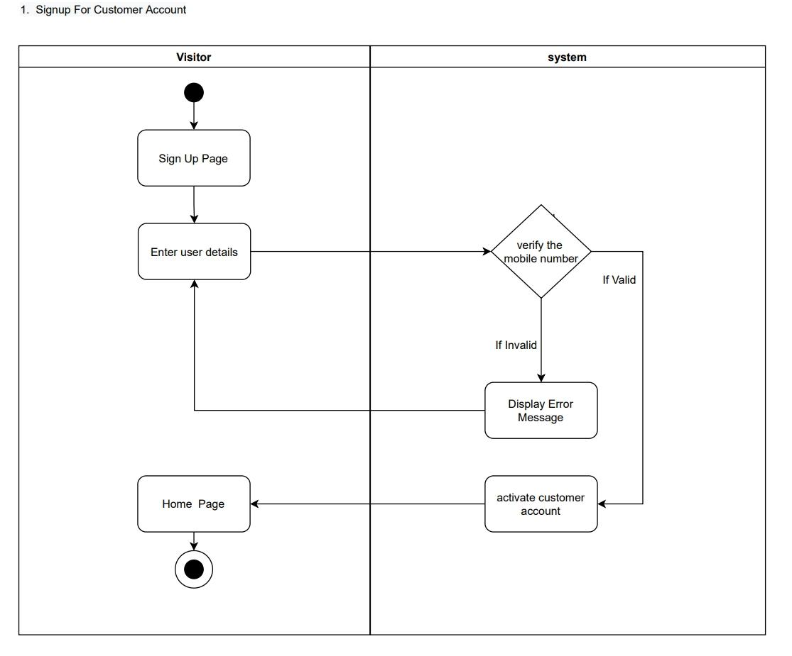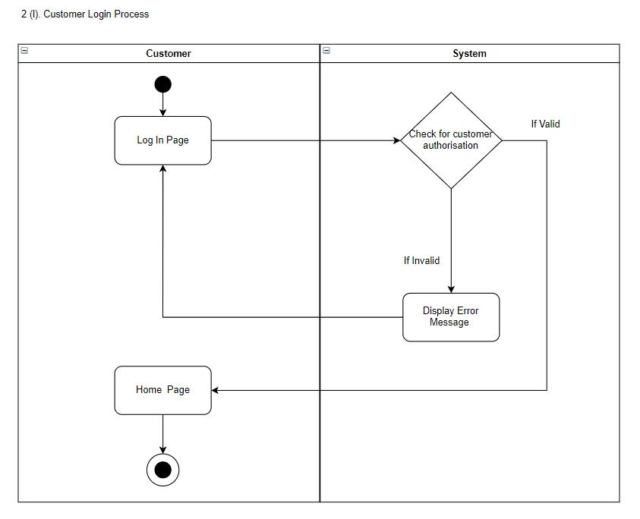

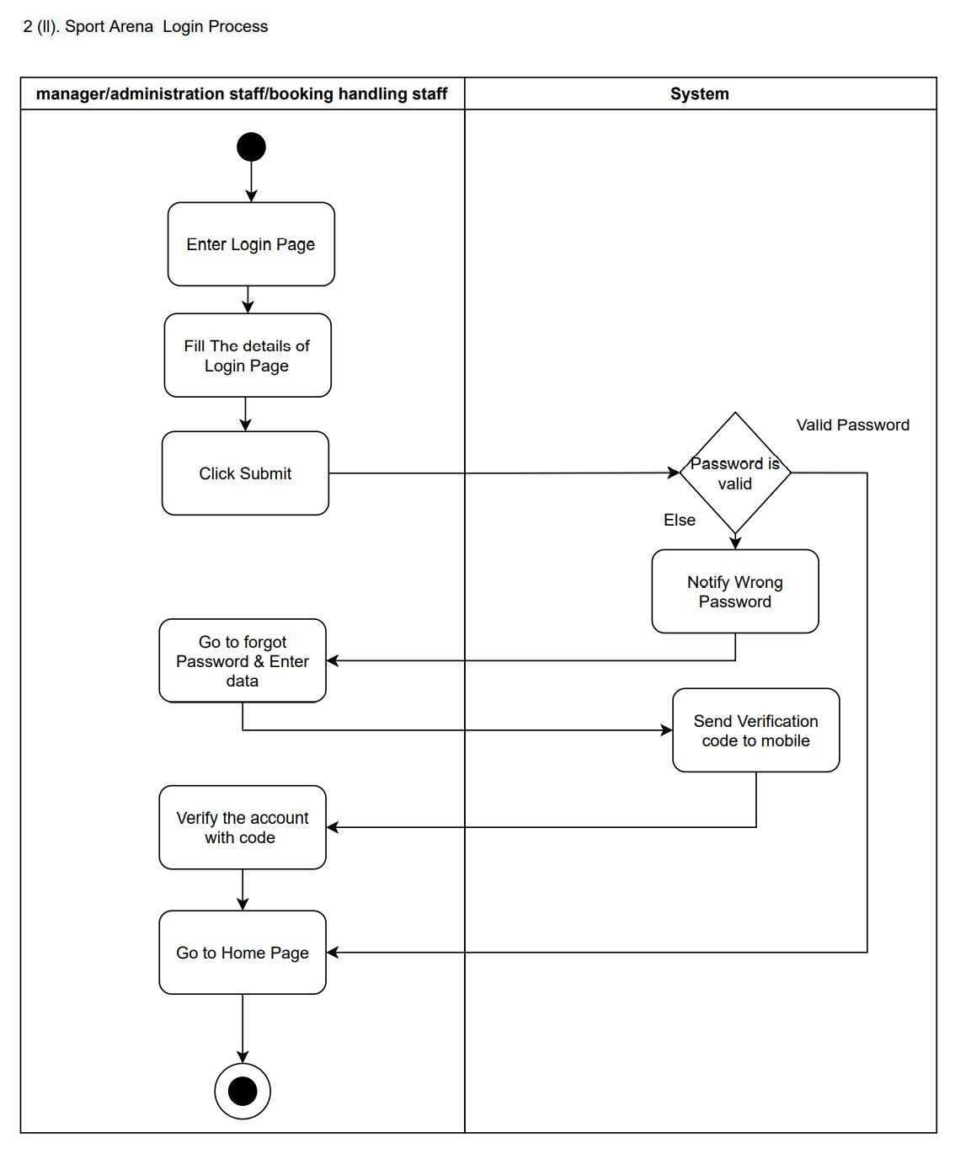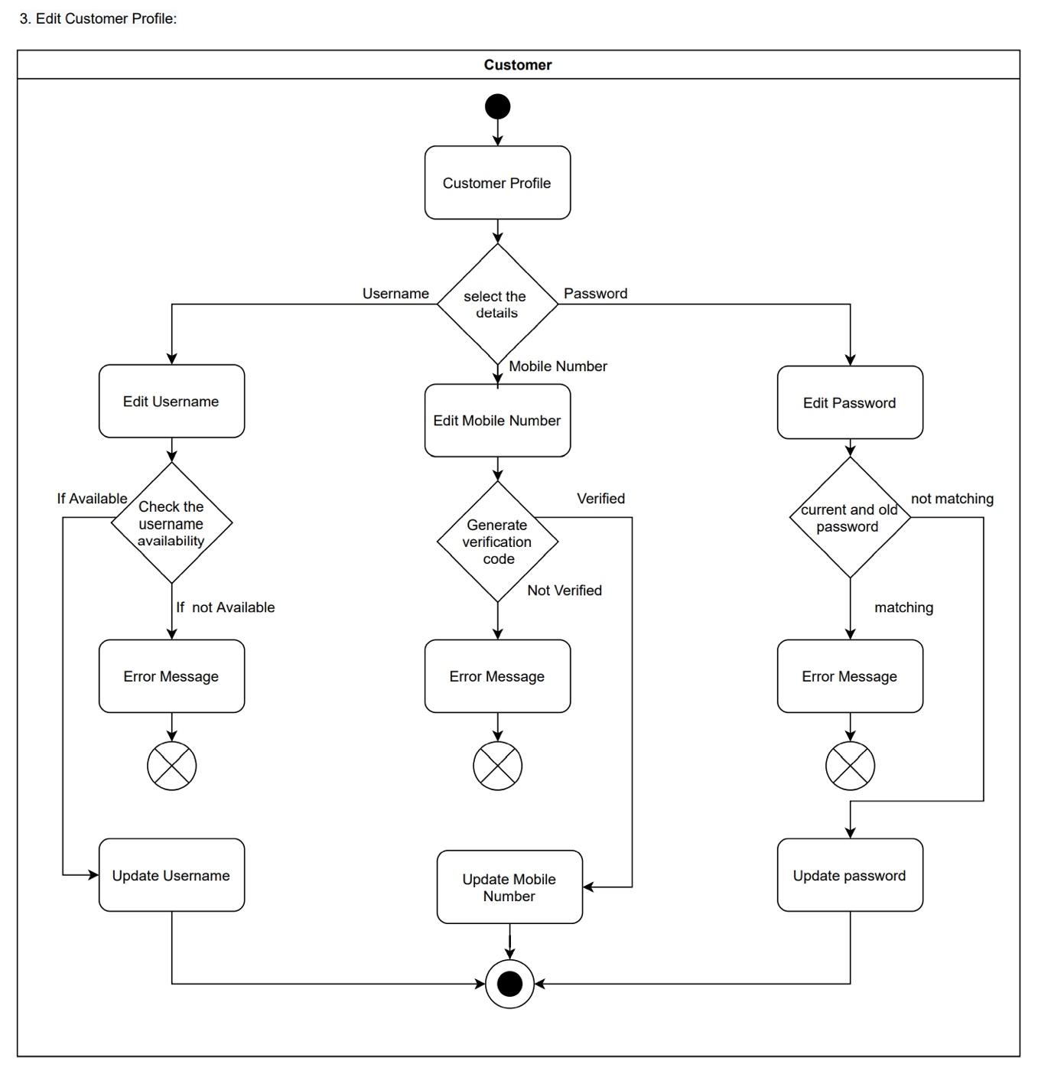

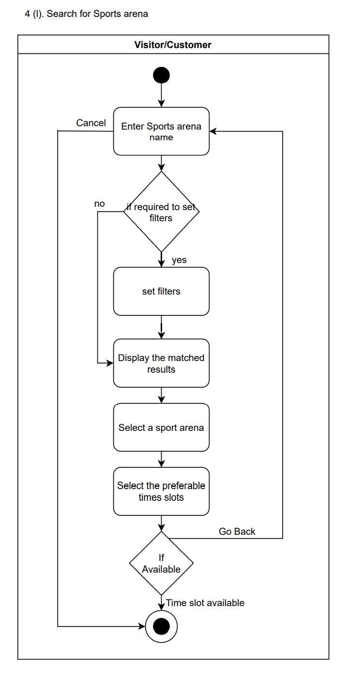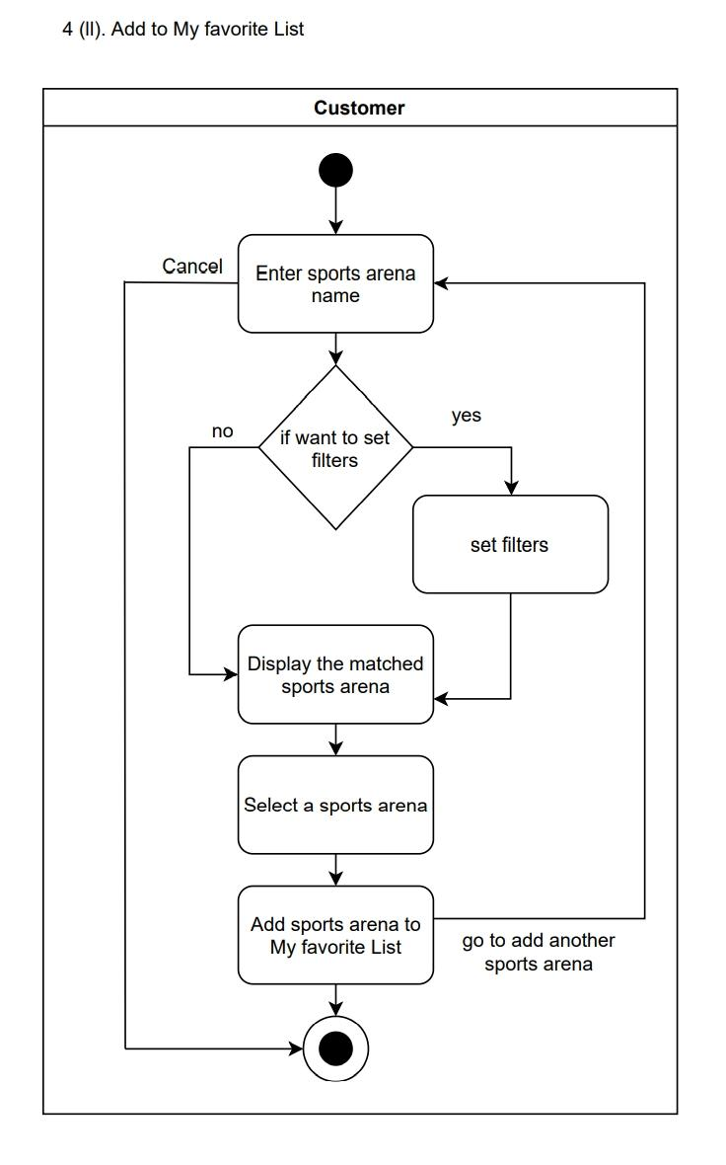

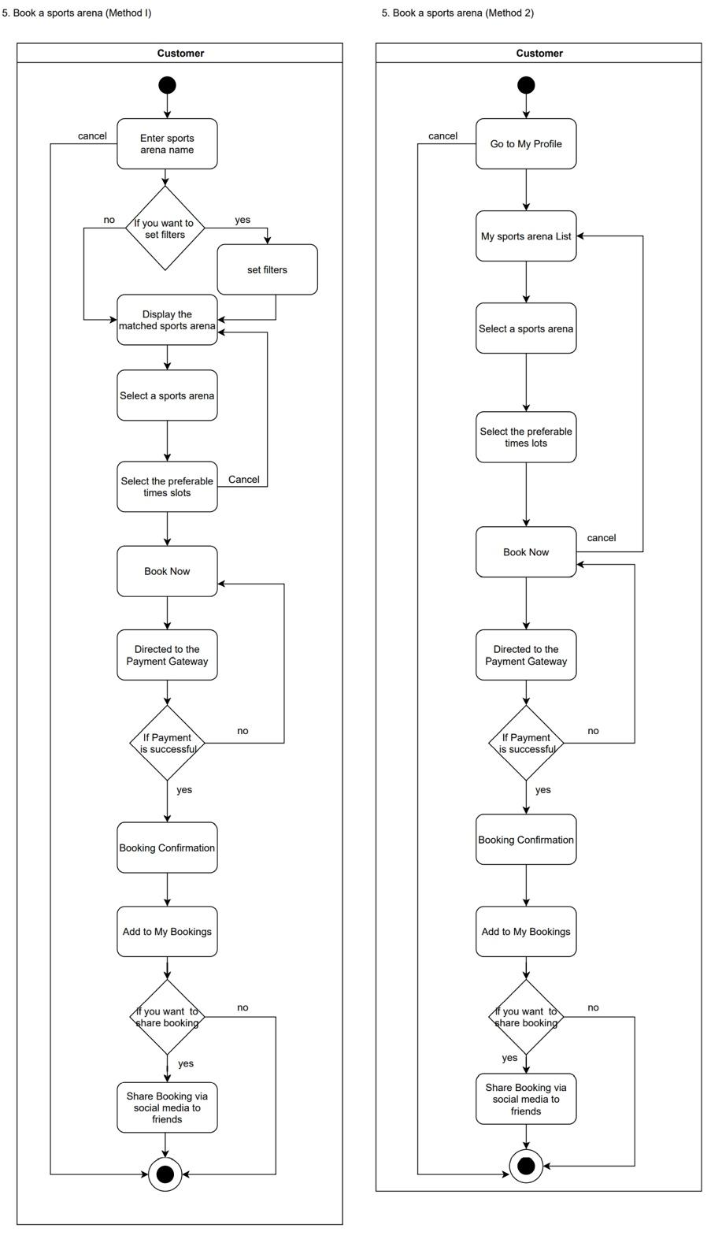

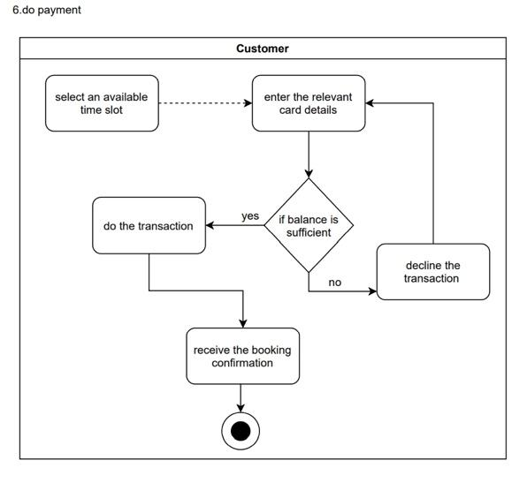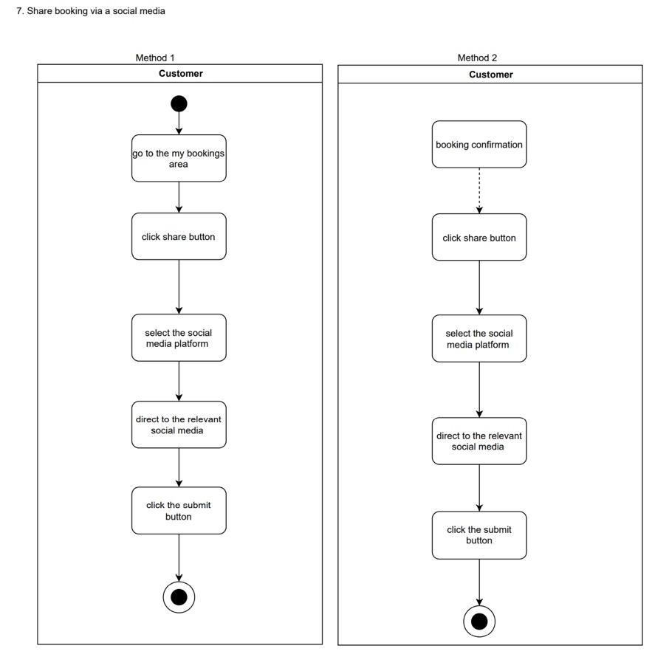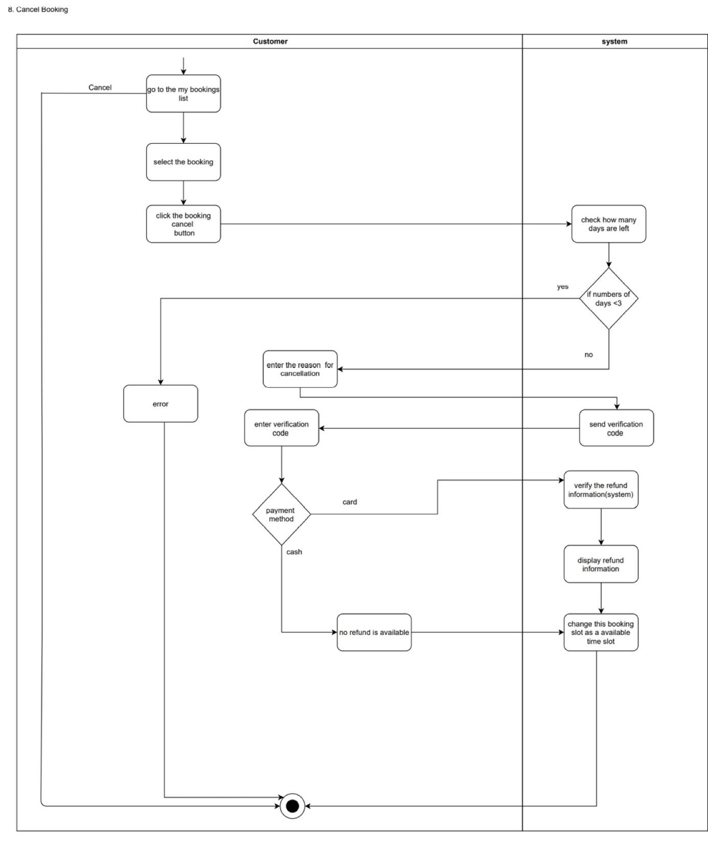

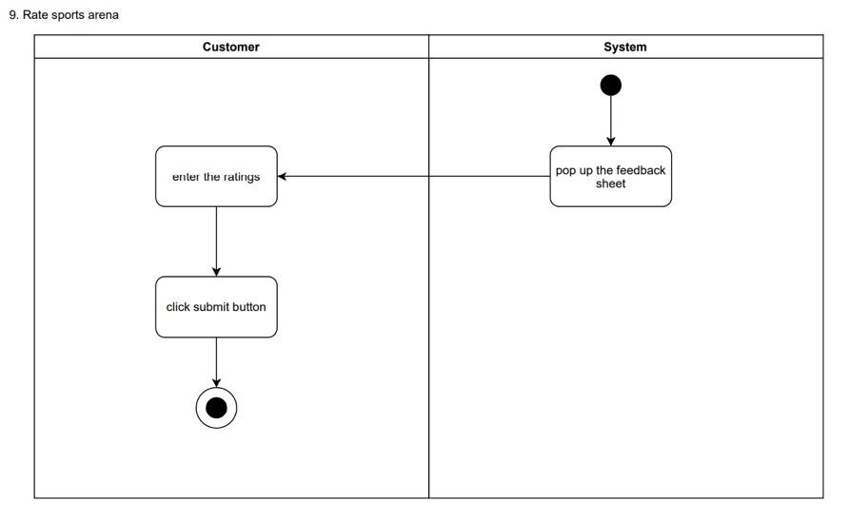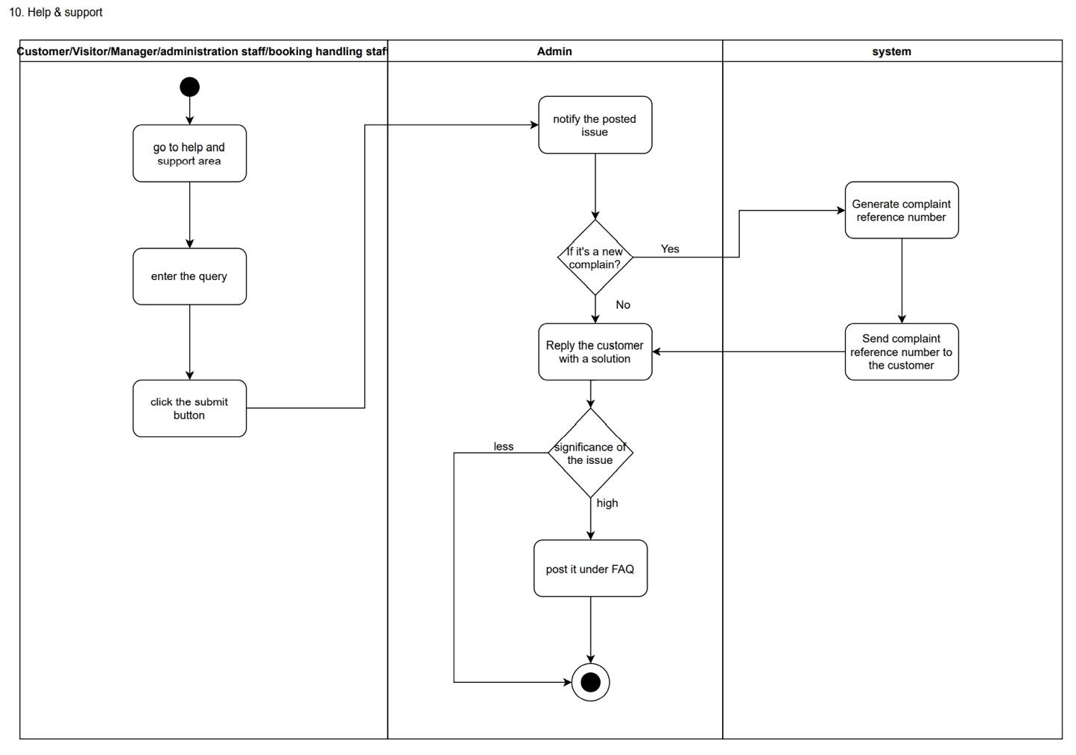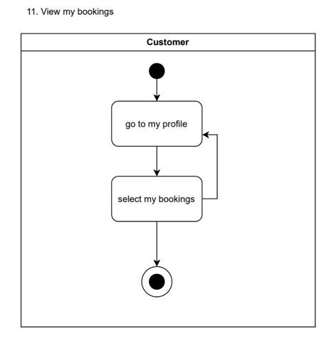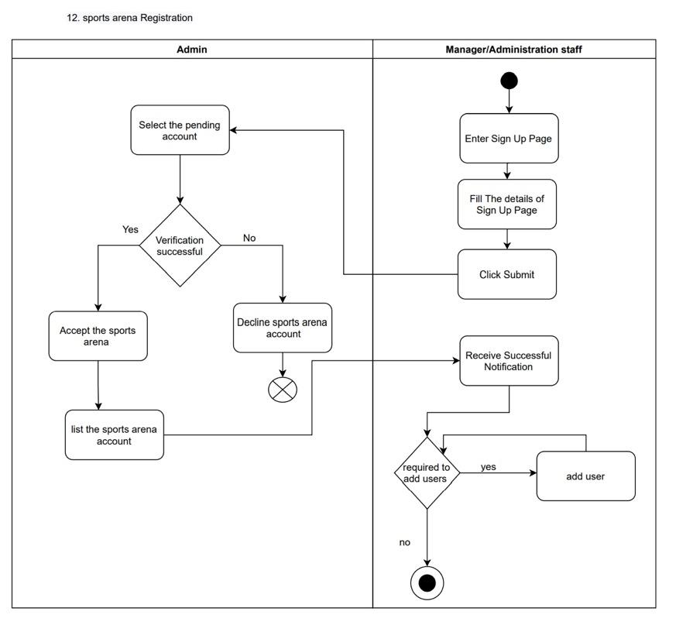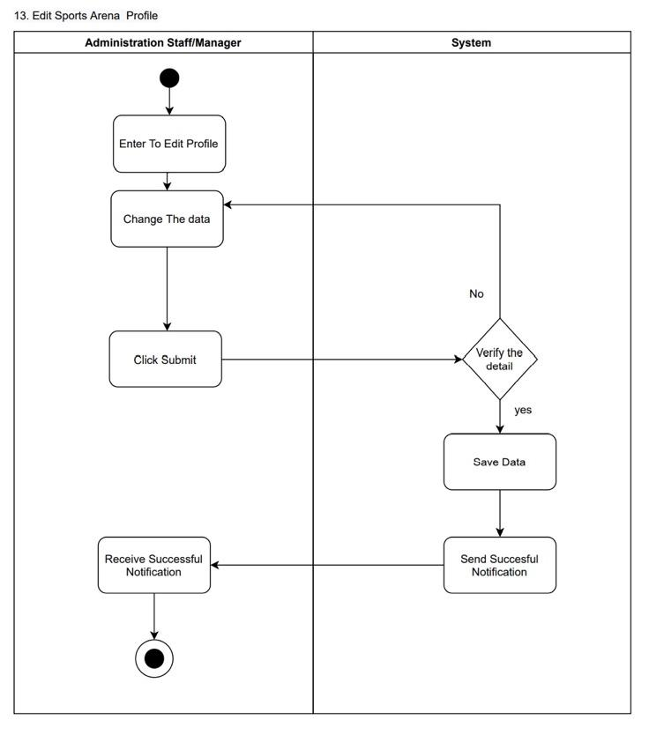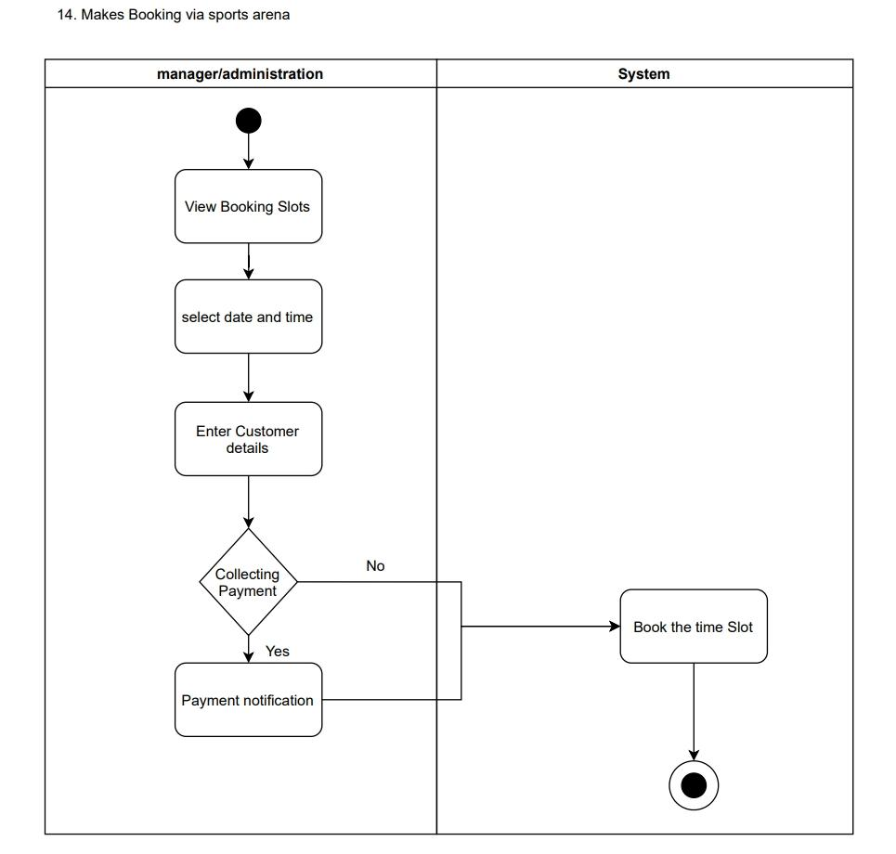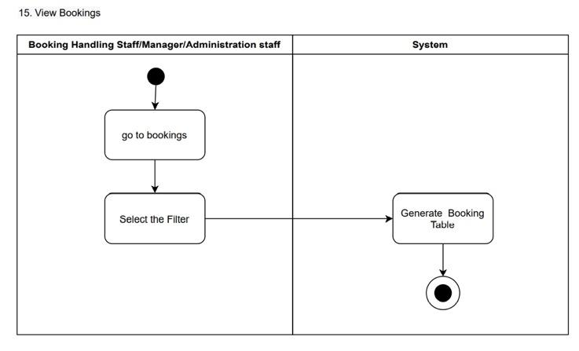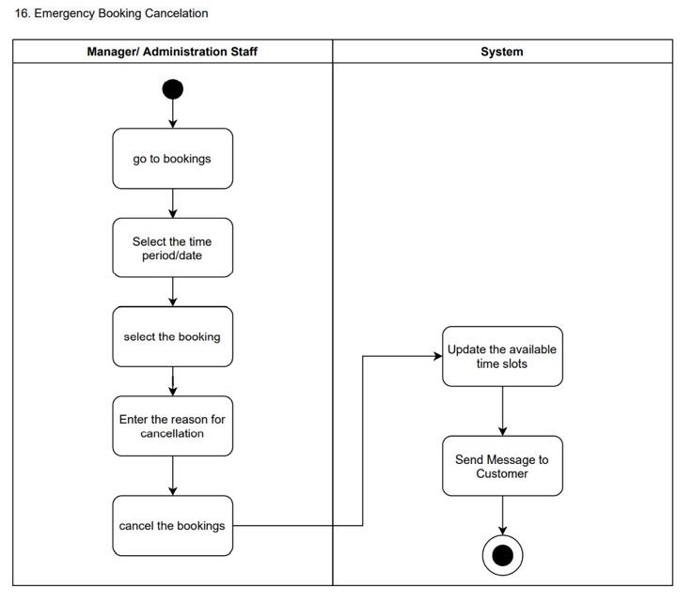

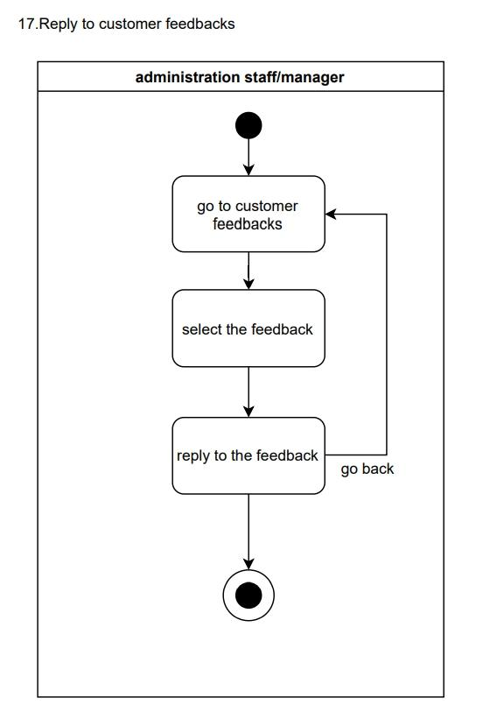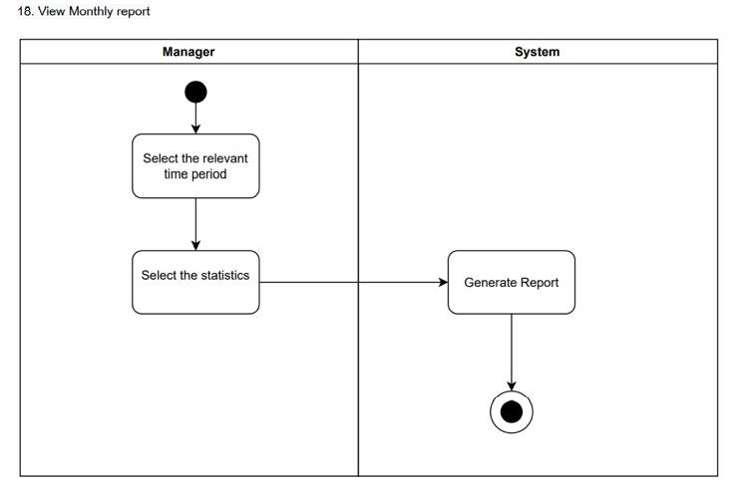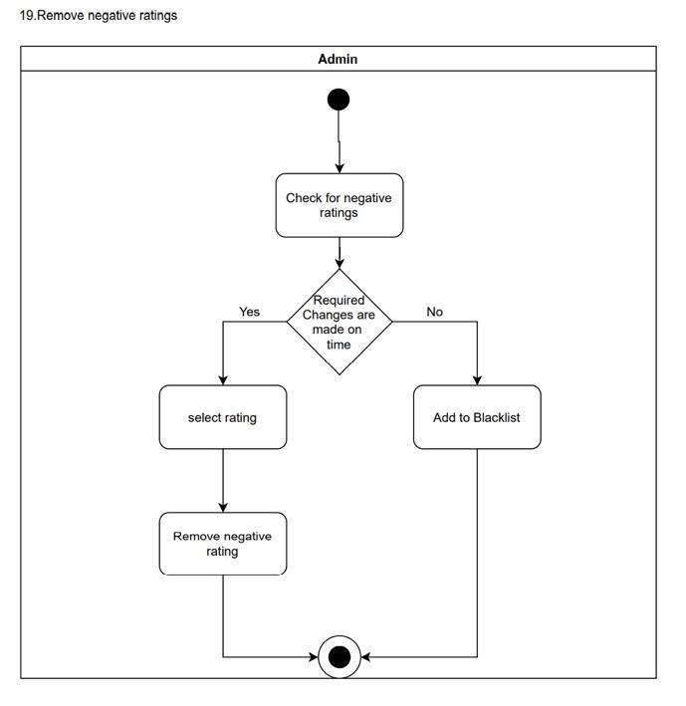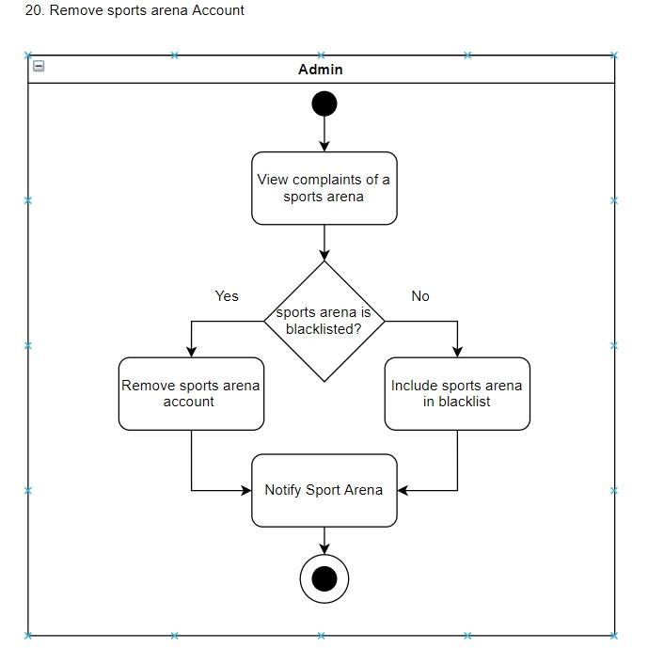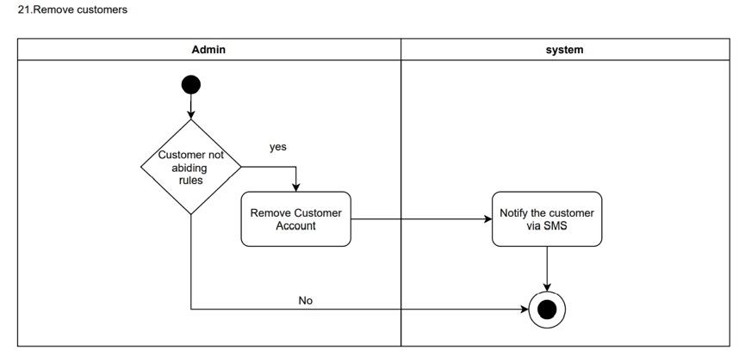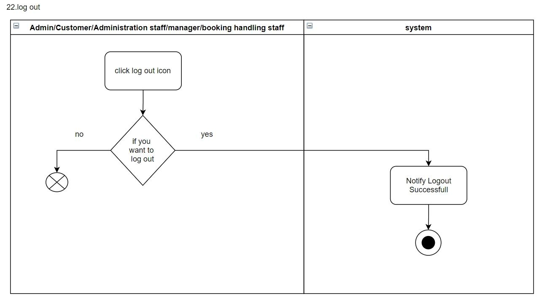

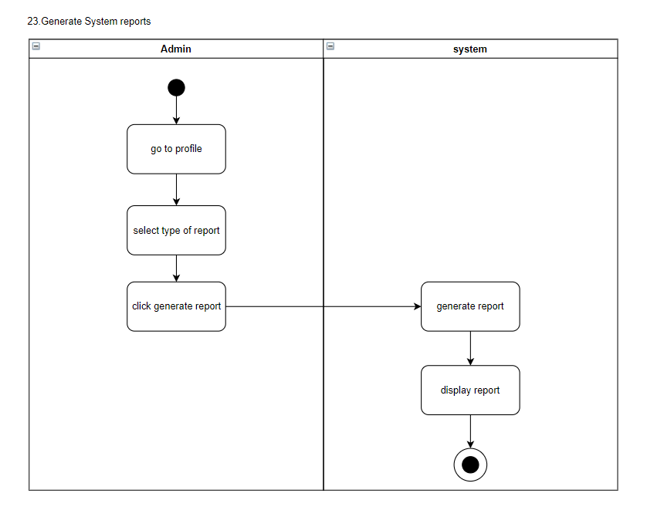

## 8.2 Quality Attributes

### 8.2.1 Security

Since security plays a vital role on our platform, we are planning to secure it as much as possible. These are some of the techniques that we are going to use, to improve our security.

* Hierarchical based login system with access controls to prevent unauthorized access from the sports arena’s end.
* For Login scenarios, Hash user authentication details are used (sha256).
* The system’s back-end servers shall only be accessible to authenticated administrators.
* For the payment, the processing of sensitive information such as card credentials and account details are stored securely.

### 8.2.2 Availability

Our system should be available at all times, except during the system maintenance period and system downtime period. Thus, the users can access the platform via a web browser with a mobile device or a personal computer or rather a laptop. In case of hardware corruption, backups of the database are retrieved from the server and saved by the system administration. Hence, our platform would be ideally 24 * 7 available.

### 8.2.3 Modifiability

We are planning to achieve the maintainability of the web application by enhancing the source code readability. Because in the future, maybe the programmers who wrote a particular piece of code, will not be available for maintenance of the system. Enhancing the readability will make it easier to maintain the system for anyone. Using the best coding practices such as commenting, using meaningful identifier/function names and using consistent indentations are our targets. And also, we are planning to develop components of the system independent from each other as much as possible. So, whenever someone wants to modify the system, it would be much easier because it will not affect the entire architecture.

On the flip side, there can also be situations where our system is not scalable and modifiable with the growing user base. In such scenarios, we would go for a new system which could handle all the required level of facilities and infrastructure.

### 8.2.4 Performance

The platform is a progressive web application. Hence the platform is loaded on top of a web browser. Therefore, the initial load time of the platform would depend upon the internet connection strength. Furthermore, it could also depend upon the device used by the user.

Also, the system should not crash when too many users are performing searches simultaneously and making booking simultaneously. We will be using the Amazon Web Services platform to automatically change the specifications of the servers to adhere to the traffic load.

### 8.2.5 Testability

Every system should be able to test for errors. When carrying out unit testing, integration testing and user acceptance testing every piece of code and every piece of design should be able to test. Testing can be conducted at different phases such as during the design time, development time and during deployment time. In order to achieve testability, we are planning to use class structures, comments along with the code structures and develop independent system module components.

### 8.2.6 Usability

Since the user base contains customers as well as sports arenas, they would prefer simple and easy to use user Interfaces that would give them a better understanding of the system and make the system easy to use.

Furthermore, we have a separate feature called the “Help & Support” feature which is available for any user to post their questions and the system admin would provide solutions to those issues and would add them to the FAQs section if those asked questions are not covered in the current FAQ list. Also, the system has navigation bars, meaningful icons and tools that enhance the user-friendliness of the system.

# Technologies

## 9.1 Front-end development of the web application.

HTML5, CSS3, and JavaScript (JS).

One of the main reasons for using the above technologies for our project work is that we are not allowed to use other frameworks which can be incorporated in developing software. However, these frontend technologies such as HTML, CSS and JS still supports a wide range of web browsers in mobile devices as well as laptops and personal computers. Since we have both the sports arenas as well as the customers as our users in our platform, we have chosen this software over the other software.

## 9.2 Back-end development of the web application.

PHP and MySQL.

A few of the most critical reasons for our group to choose these technologies over the other substitutes such as Java programming language is that it’s easy to learn and extremely flexible when it comes to programming. Furthermore, it also provides us with easy integration and compatibility over devices.

## 9.3 CASE tools for the system development process.

Draw.io, Workbox, git, GitHub, X

Draw.io is used to draw the online diagrams and share them among the group members. Since the group members are individually working on their area without having dependencies, version controlling with GitHub is more convenient for the group to carry out their project. Workbox software from google development is to be used to build our progressive web application for offline caching.

*We have chosen the above technologies for our project as we are not allowed to use any frameworks.

# Project Timeline

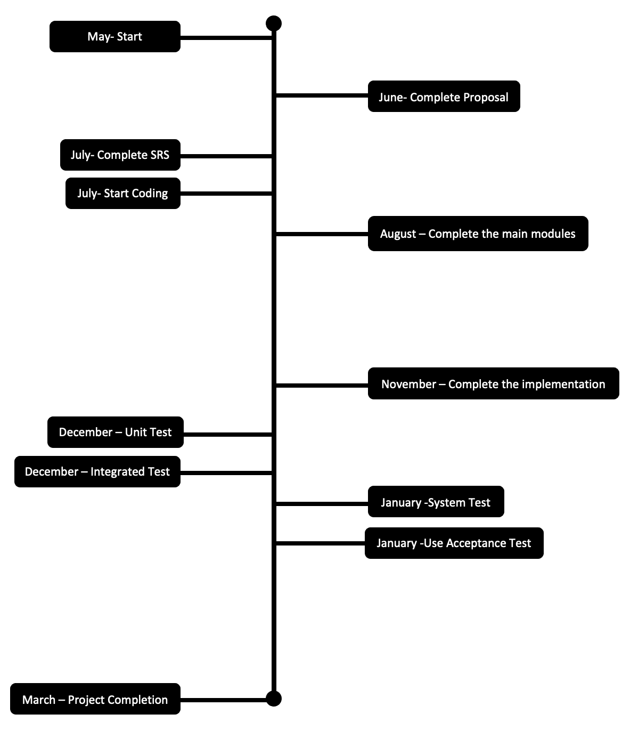

# Declaration

We as members of the project titled “Sportizza”, Certify that we will carry out this project according to the guidelines provided by the coordinators and supervisors of the course as well as we will not incorporate, without acknowledgement, any material previously submitted for a degree or diploma in any university. To the best of our knowledge and brief, the project work will not contain any material previously published or written by another person or ourselves except where due reference is made in the text of appropriate places.

|  |  |  |
| --- | --- | --- |
| 19001942 | W. L. P. MANETH WIJETUNGA |  |
| 19000286 | J. P. M. DASS |  |
| 19001312 | H.B.S. BHASHITHA RANASINGHE |  |
| 19000782 | K. P. D. PRASAD LAKSHAN |  |